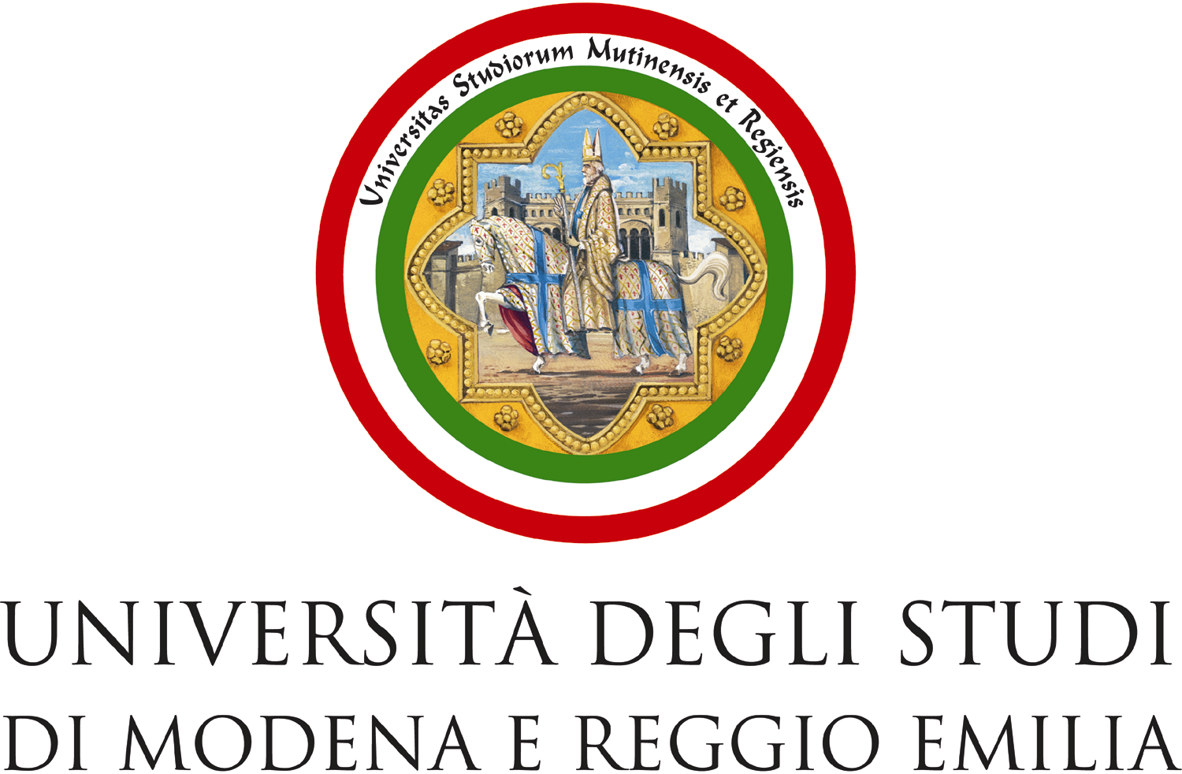

UNIVERSITA’ DEGLI STUDI DI MODENA E REGGIO EMILIA
GRADING SYSTEM

Department of Business and Economics “Marco Biagi”

Italian grade |  | Percentage | Cumulative Percentage
30 e lode |  | 4 % | 4 %
30 |  | 10 % | 14 %
29 |  | 4 % | 18 %
28 |  | 9 % | 27 %
27 |  | 9 % | 36 %
26 |  | 9 % | 45 %
25 |  | 8 % | 53 %
24 |  | 8 % | 61 %
23 |  | 7 % | 68 %
22 |  | 6 % | 74 %
21 |  | 6 % | 80 %
20 |  | 6 % | 86 %
19 |  | 4 % | 90 %
18 |  | 10% | 100%
 | DESCRIPTION OF THE INSTITUTIONAL GRADING SYSTEM.
 | Marks awarded at italian universities are on a scale from 18 to 30 scale (30 being the highest vote/18 the lowest)
 | If the mark is not over 18 then the exam performance is considered unsatisfactory so no grade is written
 | on the university student’s record book.
 | A certain number of credits are awarded for each examination.
 | One ECTS credit in the italian system corresponds to 25 working hours, taking account of all types of
 | activity required (lessons, seminars, individual or group study, etc.)
 | So 1 CFU (Credito Formativo Universitario) is equivalent to 1 ECTS credit.

