Facultad de Ciencias
Decanato

WELCOME TO THE FACULTY OF SCIENCES AT THE UNIVERSITY OF CORDOBA

The Faculty of Sciences at the University of Córdoba is conscious that your Erasmus mobility is about to start, so we would like that your stay here would be as well organized as possible. For that reason, this document summarizes the main things that you have to check before coming and during your stay here.

CORDOBA:
The province of Cordoba, one of eight that make up the Autonomous Community of Andalusia, covers 13,723.20 square kilometers, accounting for 2.7% of the country's total area and has a population of over 750,000 inhabitants. All of the University's Faculties and Schools are located in the capital, with the exception of the Technical School in Belmez. With more than 300,000 inhabitants, Cordoba is the third largest city of Andalusia. Located in the Guadalquivir River Valley, the city is bordered to the north by the Sierra Morena mountain range and to the south by the Campiña, one of the most traditional farming areas of Andalusia. The climate is Mediterranean and somewhat continental with hot, dry summers and cool, wet winters and an annual rainfall of some 600mm from October to May.

CONTACT:
Erasmus coordinator: Vice-Dean of Research, International Relationships and Mobility: Mª Teresa Roldán Arjona, PhD. internacionales.ciencias@uco.es
Erasmus tutors:
Inma: b72veagi@uco.es
Marta: b72berem@uco.es
Carlos: b72tebac@uco.es

BEFORE COMMING:
A. You must fill-up your learning agreement.
B. Do not forget your passport and your health insurance.

SCHEDULE OF ARRIVING:
First semester (September-February):
10th to 13th of September: Recommended days of arrival. It is a good idea to arrive during these days because you will have time to look for accommodation in case you need it.
14th of September:
- Arriving date to the Campus of Rabanales. Meeting with Vice-Dean of Research, International Relationships and Mobility and tutors, collect all the information about accommodation and registration. The meeting will be at 10.00 am at Paraninfo Building, ground floor.
- Registration days: From September 17th to 21st you will be organized in groups to do your registration. The exact date for you to be registered will be announced on 14th September at the meeting with Vice-Dean. You need to bring 3 photos with Spanish ID-size and white background.
24th of September: Start the first semester and the lectures. It is very important to be in this first day to get information about the courses.

Second semester (February-June/July):
You will have information about the date of arriving and registration at the end of November.
11th of February: Start the first semester and the lectures. It is very important to be in this first day to get information about the courses.

LINKS OF INTEREST
- Timetables and information about the subject
Attached to this document we provide you with a Microsoft Excel file, which contains the links to practices, classes and exams timetables. Each of the worksheets includes the links of the different degrees: Biochemistry, Biology, Chemistry, Physics and Environmental science.
It’s important for you to know that we are in a transition between our old system of “Licenciaturas” to the new ECTS system of “Grados” so you only can choose subjects of 1st, 2nd and ^{3rd} year of “Grado” and 4th and 5th year of “Licenciatura”.

- Faculty of Sciences official website:
http://www.uco.es/organiza/centros/ciencias/index_en.html
- Academic calendar:
http://www.uco.es/organiza/centros/ciencias/principal/novedades/documentos/calendario-12-13.pdf
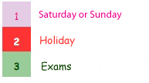

- Student Guide:
http://www.uco.es/internacionalcoopera/studentguide/index.html

- Foreign Police:

“Brigada Provincial de Extranjería y Fronteras de Córdoba” – Google maps
Address: Av. Del Mediterraneo, S/nº - 14011, Córdoba
Telephone: +34 957594570
Fax: +34 957464689

- Visa information and consulates:
http://www.uco.es/internacional/extranjeros/visados/index_en.html

- International Student Identity Card (ISIC):

Info: http://www.isic.org/
Where to get it:
Halcon Joven
Jose Cruz Conde 6 , Córdoba
Phone: +34 902401123
- Others:
University of Córdoba News in English: http://www.uco.es/uconews
Erasmus Student Network (Córdoba): http://www.esncordoba.org/
Erasmusu: http://www.erasmusu.com/

CAMPUS OF RABANALES
The University of Cordoba has three campuses located in different points of the city: Rabanales Campus, the Health Sciences Campus and the Humanities and Legal and Social Sciences Campus. In addition to these three campuses, there is also a Technical School located 60 kilometres from the city of Cordoba in the town of Belmez .

Campus of Rabanales Located at 3 kilometers from the city of Córdoba, Rabanales Campus houses modern facilities with the latest technology, making the University of Cordoba one of the best equipped universities in Europe. In addition to department headquarters, there are lecture halls, a veterinary hospital and the Juan XXIII Auditorium topped by a tower commanding panoramic views of the campus. The Central Library, modern sports facilities, the Lucano student residence hall and a train station complete the list of general services available on the campus, in addition to an R+D Technology Park which is currently under construction.
The Veterinary Faculty, the Science Faculty, the Higher Technical School and the School of Agricultural and Forestry Engineering (ETSIAM) are all located on Rabanales Campus

Transport to the Campus:
- By train: http://www.uco.es/servicios/biblioteca/centros/rab/comollegar/index.htm
- By bus: http://www.uco.es/servicios/biblioteca/centros/rab/comollegar/aucorsa.htm

CAMPUS MAP
Interactive map: http://www.uco.es/campus_rabanales/images/plano/plano.html

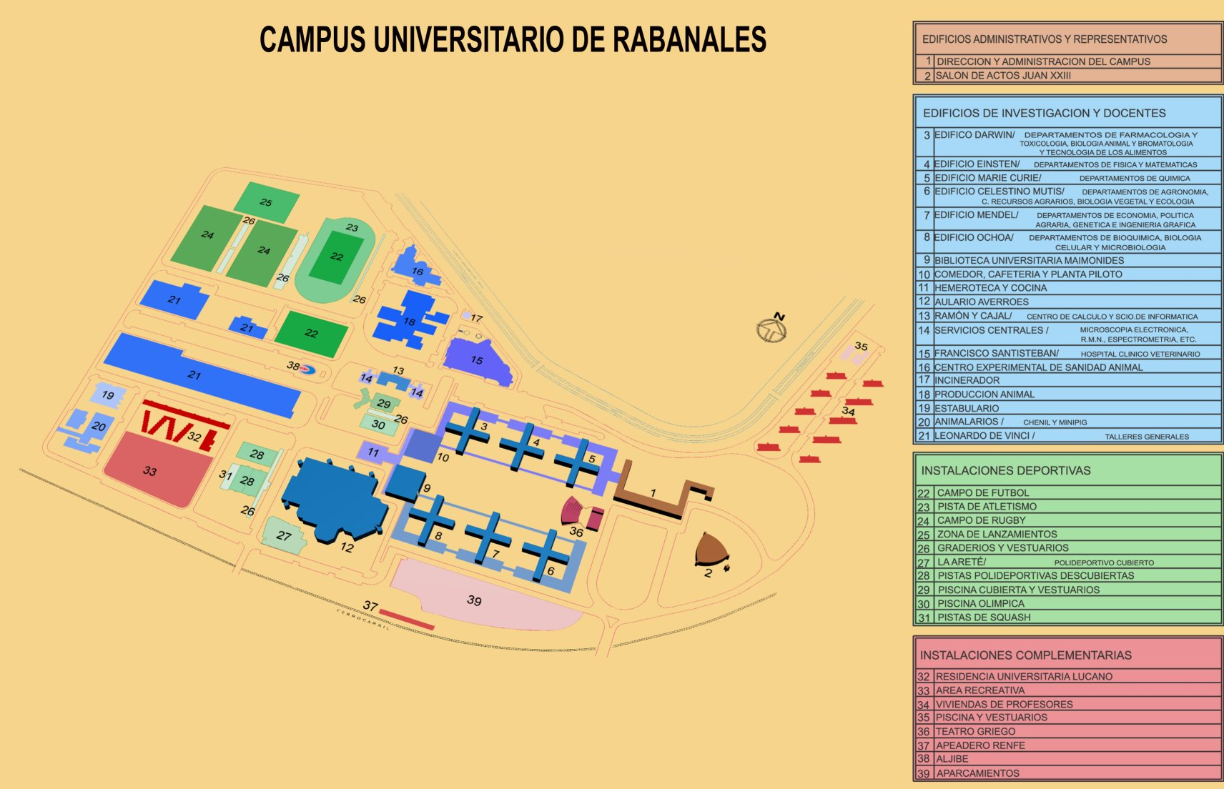

ACCOMODATION
We recommend you to find a temporary accommodation the first days in case you still haven’t flat.
Here you have some interesting links.
- Hostels: http://www.booking.com/
Some cheap and good situated hostels are:
http://www.booking.com/hotel/es/pension-internacional.es.html
http://www.booking.com/hotel/es/pension-el-portillo.es.html
http://www.infohostal.com/guia/cordoba/cordoba/alojamiento/12513/hostal-el-pilar-del-potro.html
- Youth hostel: It is a cheap option and situated in the old town. You can find them at http://www.reaj.com/info-albergue.asp?id=74
- Dormitory: http://www.uco.es/organiza/servicios/aloja/index.htm
If you are interested in searching for a flat before arriving to Córdoba, here you have an interesting link.
- http://cordoba.loquo.com/cs/vivienda/compartir-piso-alq-habitacion/302
At your arrival we will help you to find a proper accommodation.

OTHER INFORMATION OF INTEREST
The University of Cordoba has a variety of large, modern facilities offering an interesting range of services to members of both the university and the community at large.

Sports
The University's sports facilities are divided between two campuses, providing the opportunity to practice a wide range of sports and other recreational activities. The UCO also has national league men's and women's basketball teams, a men's indoor football team, and judo, tennis and hapkido teams.

Library
The Library at the University of Cordoba, whose central services are located on Rabanales Campus, contains a large collection of books as well as audiovisual and archival materials. In addition to loaning books, the Library is equipped with reference and reading rooms and the latest technology, allowing users to access the collection through card and on-line (OPAC) catalogues, as well as through electronic databases. Each of the affiliated libraries keeps users informed about the Library's holdings through diverse publications.

Languages and Translation Service
Through UCO Idiomas, the University of Cordoba offers a wide range of courses in English, French, German, Italian, Arabic and Spanish as a Foreign Language, in addition to a translating service for both general and specialized purpose.
http://www.uco.es/idiomas/

Botanical Garden
The Botanical Garden is a public foundation jointly managed by the City Council and the University. Devoted to the study of the plant world, it organizes activities and projects aimed at nature conservation and environmental awareness. The Botanical Garden carries out a wide range of social, educational and scientific activities through visits, educational programs, cultural events, exhibits, lectures, conferences, scientific and general publications, programs for the conservation of Andalusian plant resources and botanical research. The Botanical Garden is an institution of major social importance and noteworthy international prestige. Its facilities include a germplasm bank with native Andalusian plant species and one of the most important paleobotanical museums in Spain.

Other University Services
In addition to these services, the UCO offers many others of interest such as the Student Information Office or the University Ombudsman's Office. It also provides assistance through various mechanisms and foundations to promote internships in companies or provide career planning services among others.

The International Education Office at the Faculty of Sciences is looking forward to meet you in Cordoba!

