LLP ERASMUS  Partner Institution Information Form |  | Universidade de Santiago de Compostela (USC) | 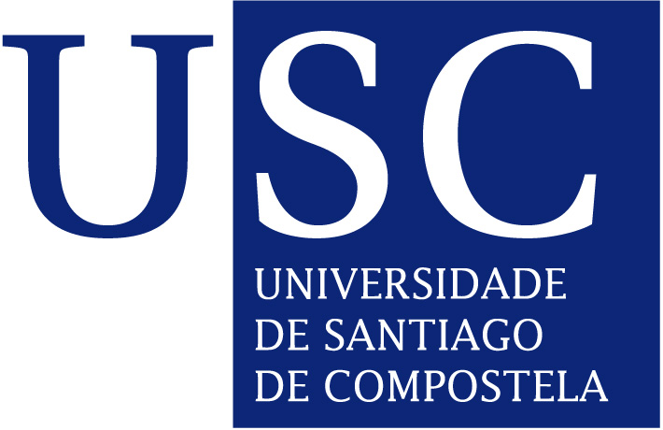
Name of the Institution |  | Universidade de Santiago de Compostela
Institution Code |  | E SANTIAG 01
Website |  | www.usc.es
Vice Chancellor |  | Juan Jose Casares Long
University courses:  Term calendars:  Study Programmes: |  | http://www.usc.es/en/titulacions/index.html  http://www.usc.es/en/perfis/estudantes/calendarios.html  http://www.usc.es/gl/titulacions/titulaionoficgrao.html
External Relations Office | Head | Enrique López Veloso  Institutional Coordinator  Casas Reais, nº 8  15782 Santiago de Compostela  España
 | Phone | +34 881 812 840 LUGO +34982823596
 | Fax | +34 881 812 843 LUGO +34982823560
 | E-mail | ore@usc.es/ erasmus@usc.es / relext@usc.es (Lugo Campus)
 | Website | www.usc.es/ore:  http://www.usc.es/en/goberno/vrrelins/portal_internacional/index.jsp  http://www.usc.es/gl/servizos/ore/ErasmusIncoming.html
 | Officers in Santiago | Head of Section: María García Penas  Administrative Officer:Gloria Ventosa  Pablo Nieto  Lorena López
 | Officers at Campus of Lugo | Anne Forryan and Bárbara Rovira (relext@usc.es)  Phone: +34 982 823 596 / 569  Fax: +34 982 823 560
Application Procedure | Deadlines | 1st semester and full year: 30 June  2nd semester: 31 November
 | Forms and Documents | - Student applications:  - https://www.usc.es/xescampusIntercambioExterna/login.htm
Health Insurance | EU students | Students must bring the European Health card
 | non EU students | Initial private insurance
 | ALL students | The USC offers a student insurance (approx 15 euros) available on enrolment.
Spanish Courses (different levels) | Taught at: | Centro de Lenguas Modernas (CLM)  http://www.usc.es/en/servizos/clm/cursos/espanol/index.html
 | Registration and enrolment | http://www.usc.es/gl/servizos/clm/cursos/espanol/matricula/index.html  All students have to take a placement test before enrolling.
 | Types | Intensive course:  September – 4 weeks – 2 hours a day  February – 3 weeks – 3 hours a day  Term course:  October to January – 3 hours a week
 | Teaching hours | 40
 | ECTS | 4
 | Fees | First course for 50€. each. Students have to buy course book and other material needed.
Language of Instruction |  | Spanish and/or Galician; teaching staff offer flexibility .  NO COURSES IN ENGLISH AVAILABLE, except those related to English Studies.
Accommodation | On Campus | Online-application for whole academic year only– Deadline:end April; exact details at:  http://www.usc.es/gl/servizos/sur/convocat_mobilidade.html  Campus maps: http://www.usc.es/es/info_xeral/localizacion/index.html
 | Off Campus | Information and support: maria.garcia.penas@usc.es  http://www.xornal.usc.es/xornal/taboleiro.html
Approximate Expenses per month | Accommodation | Approx. 300 €
 | Food | 1 Meal at the University’s restaurants: 8 €  In other restaurants:10-15 €
 | Public Transport | 1 single urban bus ticket: 1 €  10 tickets: 6 €  30 tickets: 18 €  20% off on all train tickets
 | Entertainment | Cinema– 7 €  Theatre:10 – 40 €  Going out: approx. 30 €
Activity programme for new students
http://www.usc.es/es/goberno/vrrelins/portal_internacional/acts_visitantes.html

