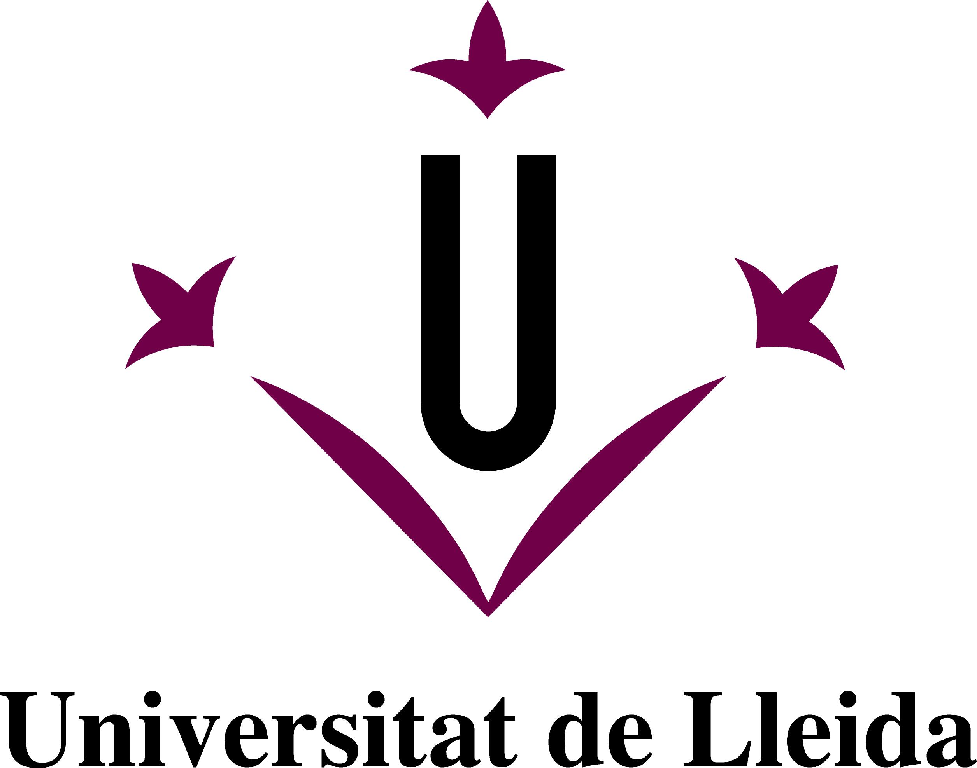

INFORMATION FOR INCOMING STUDENTS
2012/13

Name of University | University of Lleida
Erasmus code | E LLEIDA 01
In- Charge Office | Oficina de Relacions Internacionals  Universitat de Lleida  Campus de Cappont  c/ Jaume II 67 Annex  25001 LLEIDA  Catalonia, Spain  Phone: +34 973 00 3534  Fax: +34 973 00 3531  E-mail: ori@int.udl.cat
Staff | Vice- Rector | Coordinator |  | Incoming  Students | Outgoing  Students
 | Astrid Ballesta  vric@udl.cat | Josep M. Martí  josepmaria.marti@udl.cat |  | Joan Carles Mercader  Paula Obregón  incoming@int.udl.cat | Eva Moscatel  Fermina Berzosa  ori@int.udl.cat
Campuses, faculties and schools | Rectorate Campus  Faculty of Arts  Cappont Campus  Faculty of Law and Economics  Faculty of Educational Sciences  Polytechnic School |  | Health Sciences Campus  Faculty of Medicine  Faculty of Nursing  Campus of the School of Agricultural Engineering  School of Agricultural and Forestry Engineering
Affiliated Centres
University School of Labour Relations
National Institute of Physical Education of Catalonia- Lleida Branch

ACADEMIC INFORMATION

Academic offer | You can check the academic offer of the University of Lleida in the following link  http://www.udl.cat/en/studies/studies_all.html
Academic offer in English | You can check the academic offer in English of the University of Lleida in the following link  http://www.etsea.udl.cat/en/mobility/Subject_En.html
Academic Calendar | First semester 2012-13  Welcome activities: from 30/08/12 to 10/09/12  Christmas break: form 22/12/12 to 06/01/13  Lessons and exams: from 12/09/12 to 01/02/13  Second semester 2012-13  Welcome activities: to be determined  Easter break: from 23/03/13 to 01/04/13  Lessons and exams: from 04/02/13 to 21/06/13
Optional exams period:
First semester: from 01/07/13 to 05/07/13
Second semester: from 08/07/13 to 12/07/13

Teaching languages | The teaching languages in the University of Lleida are Catalan, Spanish and English.  Catalan is the official language at the UdL. The linguistic policy regulation of the University of Lleida establishes that Catalan, Spanish and English are the working languages in the UdL.  Teaching staff decides the language of instruction. The language must be previously announced.  Nevertheless, students have the right to use the language they prefer but this one must be announced at the beginning of the course.
Credits | 1 credit ECTS is equivalent to 25hs of student work. A whole semester is equivalent to 30 ECTS.
Grading system | Qualification | Grading scale over 10
 | Excellent  Good  Pass  Fail  Exam not taken | 9- 10  7- 8.99  5- 6.99  0- 4.99  -
Courses without qualifications
Apte: Pass
No apte: Fail

APPLICATION

- Nomination
- Application form on line
- Sending the required documentation

Application form on line | http://www.udl.cat/serveis/ori/estudiantat_estranger/eng/application.html
Deadline | First semester 2012/13  - Fill in application form before July 1st  - Sending the required documentation before July 15th  Second semester 2012/13  - Fill in application form before December 1st  - Sending the required documentation before December 15th
Visa and residence permit | Visa and entrance in Spain  European Union citizens: with the valid passport and/or the identity card.  Non European Union citizens: the International Relations office will ship off the acceptance letter to process the student visa.  Residence permit:  You can find information about the residence permit in the following link:  http://www.udl.cat/serveis/ori/estudiantat_estranger/eng/infoeng/entry.html

USEFUL INFORMATION

How to get to Lleida | Information about how to get to Lleida can be found in the following link:  http://www.udl.cat/serveis/ori/estudiantat_estranger/eng/infoeng/to.html
Living in Lleida | Students will need between 600 € and 700 € per month to face to the expenses of housing and subsistence in Lleida.
Accommodation | The International Relation office and the University Information and Support Service help students to find accommodation.  For more information, please visit:  http://www.udl.cat/serveis/ori/estudiantat_estranger/eng/infoeng/accommodation.html
Welcome week | Students are advised to participate in the Welcome Weeks organized by the International Relations office at the ending of January (second semester) and at the ending of August (first semester).  Check the programme of the Welcome Weeks in the following link  http://www.udl.cat/serveis/ori/estudiantat_estranger/eng/academicactivities.html
Language courses | The Language Service offers Catalan courses for incoming students during the Welcome Weeks. Moreover, it offers Spanish, English, French and Occitan courses.  For further information about registration procedures, timetables and prices please visit the following link:  http://www.udl.cat/serveis/sl/en/information.html
Health insurance | It is mandatory for incoming students to make their own arrangements for travel and health insurance cover the entire period of studies in Lleida. For further information please visit the following link:  http://www.udl.cat/serveis/ori/estudiantat_estranger/eng/infoeng/insurance.html
Accident insurance | It is mandatory for incoming students to heir the accident insurance when they register at the University of Lleida.

