ECTS grades replaced by ECTS Grading Table (EGT)

In order to facilitate the mobility of students within Europe, the European Directorate General of Education and Culture in Brussels issues recommendations on how grades should be transferred between universities in different European countries. New recommendations are published every few years in the ECTS Users’ Guide.

Until 2009 national/local grades were to be translated to what was known as the ECTS scale comprising the passing grades A-E. With the ECTS Users’ Guide 2009, however, the ECTS scale was abolished, since it had proved to be difficult to implement and therefore had not been generally accepted. It was replaced by the ECTS Grading Table (EGT), which is a table presenting the distribution of the national/local grades.

Since January 2011 it is possible to print transcripts of records including EGT from Ladok (the national system for documentation of academic information at higher education institutions in Sweden). The EGT is generated automatically and based on all grades awarded on the course from the start until and including the date when the present student was graded. However, the EGT of a specific course is normally only included in the transcript of records if grades from the course are available for a period of at least two years. Figure 1 on page 2 shows an example of a transcript of records including EGT.

Beginning the autumn semester of 2011, Karlstad University strictly follows the recommendations of the European Union. Thus, we do not issue ECTS grades but offer all students transcripts of records including the EGT. Students may also print a transcript of records including the EGT themselves from My page at www.kau.se.

How can grades given at Karlstad University be interpreted?
Use the EGT given for each course in the student’s transcript of records to transfer her/his course grade expressed to the grading scale of the student’s home university. Recommendations on how to do this are given in the ECTS Users’s Guide 2009, page 42 f. Three examples are given on page 3 of this document.

How can the student obtain a transcript of records including the EGT?
If the student does not have a transcript of records including the EGT, she/he can either print one from My page at www.kau.se or contact the Student Centre at Karlstad University to have one sent. The address is: Student Centre, Karlstad University, S-651 88 Karlstad, Sweden. E-mail: studentcentrum@kau.se.
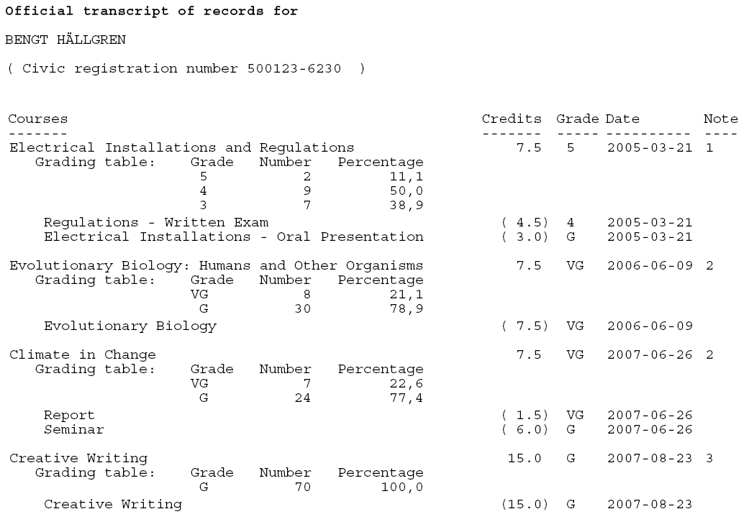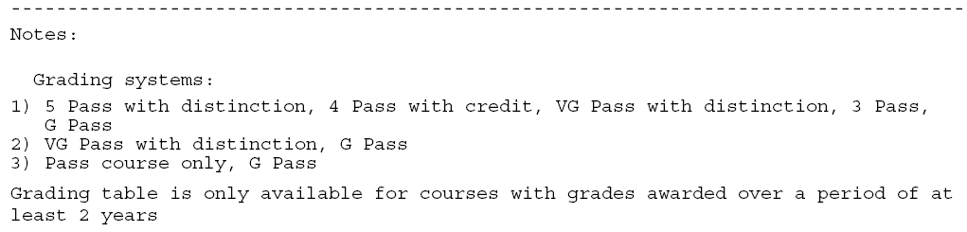
Sven Svensson
123456-7890

Fig. 1 – Excerpt from a transcript of records including the ECTS Grading Table (EGT). Red frames added in figure to emphasize EGT.
Transfer of grades from Karlstad university gading scales to home university scale

This page illustrates how grades from Karlstad University may be transferred to the local grading scale of the student’s home universitiy. In order to performe the transfer, one must know the grade distribution of an equivalent course or programme at the home university.

The examples are taken from the transcript of records on page 2. In the examples the now abolished ECTS scale is used as home university grading scale. Since Swedish grading scales generally comprise fewer steps than those in other countries, a certain ambiguity will remain.

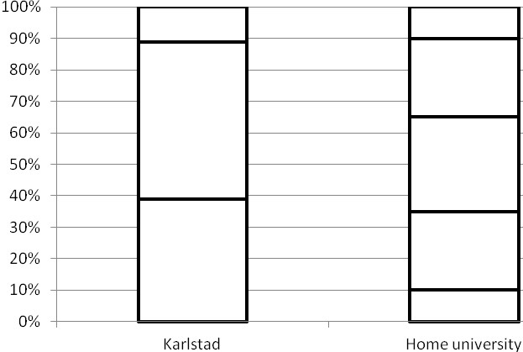
5 – 11.1 %
4 – 50.0 %
3 – 38.9 %
A – 10 %
B – 25 %
C – 30 %
D – 25 %
E – 10 %
Example 1
A – 10 %
B – 25 %
C – 30 %
D – 25 %
E – 10 %
Course: Electrical Installations and Regulations, 7.5 credits.
EGT: See page 2.
Result: 5 A, 4 B or C or D, 3 D or E

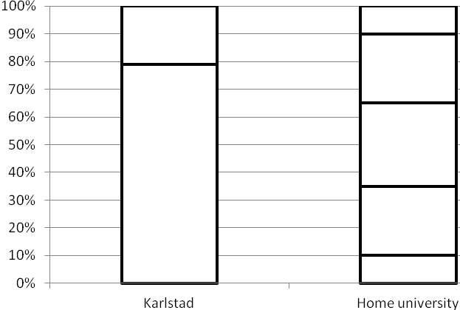Example 2
A – 10 %
B – 25 %
C – 30 %
D – 25 %
E – 10 %
VG – 21.1 %
G – 78.9 %
Course: Evolutionary Biology – Humans and Other Organisms, 7.5 credits.
EGT: See page 2.
Result: VG A or B, G B, C, D or E

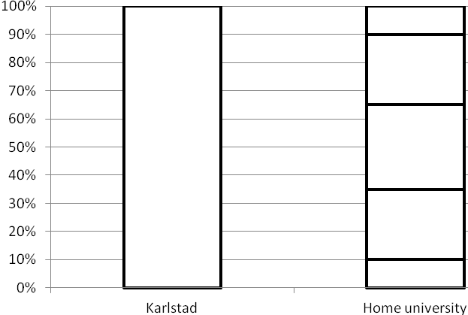Example 3
A – 10 %
B – 25 %
C – 30 %
D – 25 %
E – 10 %
G – 100 %
Course: Evolutionary Biology – Humans and Other Organisms, 7.5 credits.
EGT: See page 2.
Result: Only pass grade is awarded on the course. No grade transfer is possible.

http://ec.europa.eu/education/lifelong-learning-policy/doc/ects/guide_en.pdf
ECTS Users’ Guide 2009, page 41 f.
If grades issued after the present student was graded were to be included in the calculation, the student would find different EGTs on transcripts of records printed on different occasions.

