
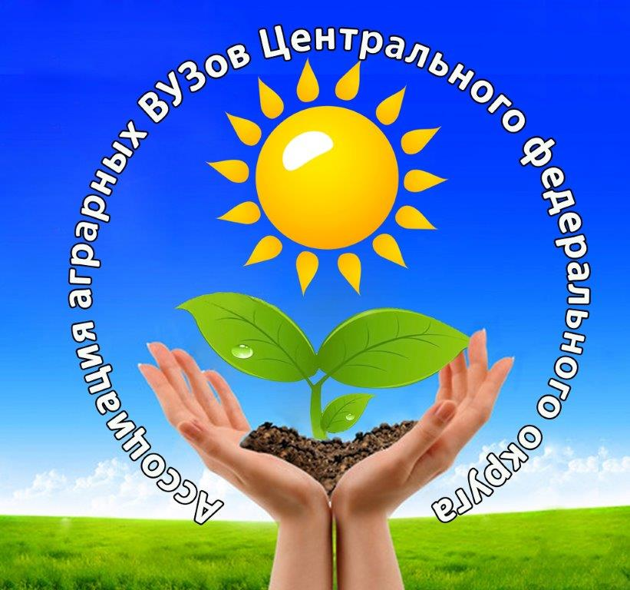

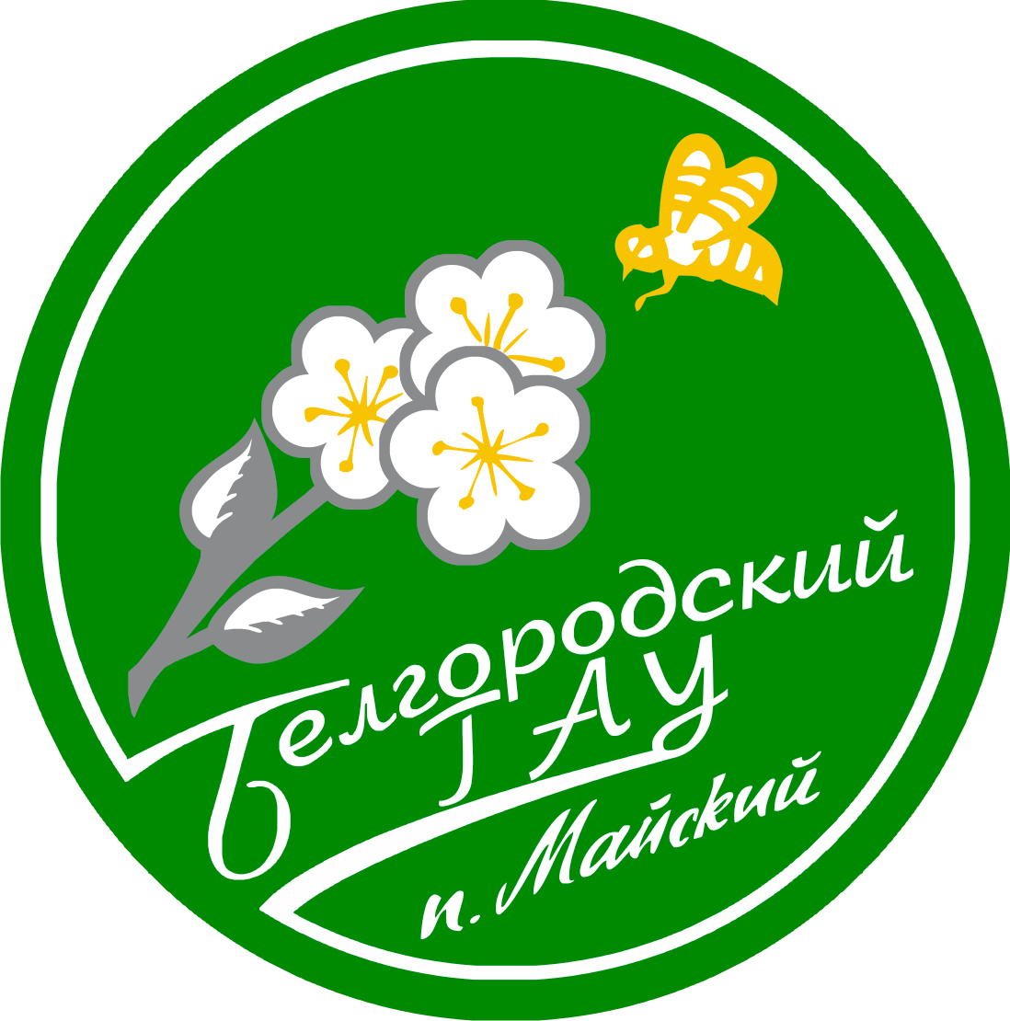


INTERNATIONAL SUMMER SCHOOL
FROM FIELD TO FORK – FROM TREE TO MOUTH:
Agricultural Production for Food Security and Import Substitution

Application form
FAMILY NAME
NAME
GENDER | □ Male □ Female
DATE OF BIRTH (DD/MM/YY)
INSTITUTION
FACULTY / DEPARTMENT
YEAR OF STUDY
TELEPHONE
E-MAIL
CORRESPONDENCE ADDRESS
POSTCODE
COUNTRY
SUMMER SCHOOL | □ Belgorod and Michurinsk  I will participate in □ Michurinsk  □ Belgorod

Date____________________ Signature________________________

