
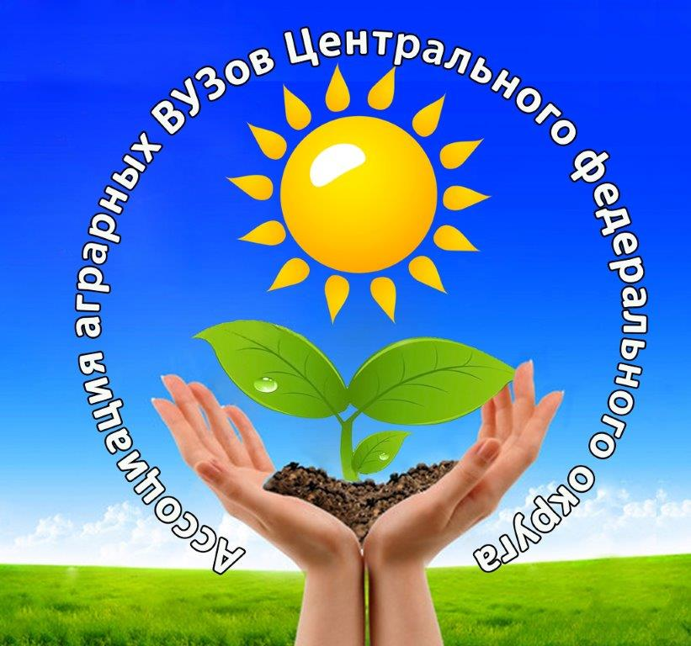





International Summer School
“From Field to Fork from Tree to Mouth”
Agricultural Production for Food Security and Import Substitution
(Belgorod and Tambov regions)

PRELIMINARY PROGRAMME

Belgorod State Agricultural University
July, 29 - August 5, 2018
Time | Activity
29.07.2019 Arrival (Monday)
17.00 | Arrival, accommodation, dinner
30.07.2019 (Tuesday)
Agricultural Production, education and science in Russia and Belgorod region
09.30 – 10.30 | Breakfast
10.30 – 11.00 | Opening Ceremony, Presentation of the University (Rector)
11.00 – 13.00 | Presentation «Development of Agriculture in Russia and Belgorod Region»
13.00 – 14.00 | Lunch
14.00 – 16.00 | Excursion to the campus
16.00 – 18.00 | Language practice (optional): “Easy Russian”
18.00 – 19.00 | Dinner
31.07.2019 (Wednesday)
Agricultural Production in Belgorod region
09.00 – 09.30 | Breakfast
09.30 – 10.00 | Transfer to Bessonovka
10.00 – 11.30 | Presentation «Milk production and processing»
11.30– 13.00 | Visit to the Agirfarm “Kolkhos Gorina”
13.00 – 14.00 | Lunch
14.00 – 15.00 | Free time (shoping)
15.00 | Departure to the holiday campus
15.30 – 18.00 | Teambuilding course
18.00 – 22.00 | Picnic, dance party
01.08.2019 (Thursday)
Agriculture in Belgorod region. Poultry Production and Processing
8.30 – 9.00 | Breakfast
9.00 – 9.30 | Transfer to Belgorod (Razvitije)
9.30 – 10.15 | Presentation «Poultry Production in Belgorod Region»
10.15 – 11.30 | Visit to the poultry farm in Razumnoje
11.30 – 12.00 | Transfer to Belgorod
12.00 - 13.00 | Ski (Megagrin)
13.00- 14.00 | Lunch
14.00 – 16.00 | Visit to the Ice-cream production company «Bodraya Korova»
16.00 – 16.30 | Transfer to Mayskiy
16.30 – 18.00 | Language practice (optional): “Easy Russian”
18.00 – 19.00 | Dinner
02.08.2019
Agriculture in Belgorod region. Pork Production and Processing
09.00 – 10.00 | Breakfast
10.00 – 11.15 | Presentation «Development of Pork Production in Belgorod Region»
11.30 – 13.00 | Presentation «Meat Processing»
13.00 – 14.00 | Lunch
14.00 – 14.45 | Transfer to Krapivinskiye Dvory
14.45 – 17.15 | Visit to the Slaughterhouse of the Pig Company AgroBelogorie
17.15 – 18.00 | Transfer to Mayskiy
18.00 – 19.00 | Dinner
03.08.2019
Biogas production + Cultural trip
9.00 – 10.00 | Breakfast
10.00 – 11.00 | Presentation «Biogas production»
11.00 – 12.00 | Transfer to Prokhorovka
12.00 – 13.00 | Visit of the Biogas Station “Luchki” LLC “AltEnergo”
13.00 – 14.00 | Lunch (Blindag)
14.00 -17.00 | Departure to the village Kostroma  Excursion to the Open Space Museum “Klyuchi” (Voyage)
17.00 – 18.00 | Transfer to Belgorod
18.00 – 19.00 | Dinner
04.08.2018
Cultural trip
9.00 – 10.00 | Breakfast
10.00 – 13.00 | Excursion to the city (+ shoping center)
13.00 – 14.00 | Lunch
14.00 – 17.00 | Picnic Park visit
17.00 – 18.00 | Dinner
18.00 – 23.00 | Visiting of the Celebration Events of the Day of the City (Salute)
05.08.2018
Closing Ceremony, Departure
9.00 – 10.00 | Breakfast
10.00 - 11.00 | Free time
11.00-12.00 | Closing and Certificate delivery Ceremony (Rector)
12.00 | Departure to Kursk
Michurisnk State Agrarian University
August 5-11, 2018
Time | Activity
05.08.2018 Arrival
13.30 | Arrival, accommodation, lunch, free time
18.00-19.00 | Dinner
19.00 – 21.00 | Excursion to the city
06.08.2018
Expert training for agricultural production (Michurinsk State Agrarian University – role in the science-city development))
8.30 – 9.30 | Breakfast
9.45 – 10.30 | Presentation 1: Summer school opening and university presentation
10.30 – 12.00 | Presentation 2: Association of agrarian education in the central part of Russia as an expert training resource for food security provision
12.00-13.00 | Excursion to the university campus
13.00 – 14.00 | Lunch
14.00 – 15.30 | Presentation 3. Agricultural production in Tambov region. Michurinsk as a science city in horticulture
15.30 – 17.00 | Visit to the Federal Research Center of Horticulture
17.00 – 18.00 | Language practice (optional): “Easy Russian”
18.00 – 19.00 | Dinner
07.08.2018
From Field to Fork
8.30 – 9.30 | Breakfast
9.45 – 11.15 | Presentation 4: Import substitution and food security provisions in Tambov region and Central Black Earth Zone of Russia: horticulture and crop production
11.30 – 13.00 | Master-class: Soil science for high yields and soil ecology. (Trip field to the university experimental farm “Komsomolets”. Soil profile analysis). In cooperation with the fertilizers production company “August”.
13.00– 14.00 | Lunch
14.00– 18.00 | Excursions to the vegetable production company “Teplichnoye”.
18.00 – 19.00 | Dinner
19.00 – 20.00 | Cultural aspect (optional): Making ancient Russian talisman dolls with your own hands.
08.08.2018
An Apple a Day for Russia and Faraway
8.30 – 9.30 | Breakfast
9.45-11.15 | Presentation 5: Horticulture as the key issue of Tambov Region development. Horticultural traditions of Michurin and Budagovskiy.
11.30-13.00 | Presentation 6: The ways to intensify horticulture in Russia. High density orchards and the environment.
13.00 – 14.00 | Lunch
14.00 – 16.00 | Visit to the National Association of Fruit Growers
16.00 – 17.00 | Master class at the experimental orchard of the National Association of Fruit Growers
17.30 – 18.00 | Cultural aspect (optional): House-museum of I.V. Michurin
18.00 – 19.00 | Dinner
09.08.2018
From Tree to Mouth
8.30 – 9.30 | Breakfast
9.45 – 11.15 | Presentation 7: Storage and Processing of Fruit and Vegetables for Healthy Nutrition
11.30 – 12.00 | Visit to the university laboratory of storage technologies development
12.00 – 13.30 | Presentation 8: Functional Food Production: new recipes from the university functional food laboratory.
14.00 – 15.00 | Lunch
15.00 – 16.00 | Master class in apple chips production
16.30 – 18.00 | Cultural aspect: visit to the house museum of A.M. Gerasimov and Gerasimov’s Gicture Gallery.
18.00 – 19.00 | Dinner
19.00 – 20.00 | Language practice (optional): Making bridges – German Derivatives in the Russian Language
10.08.2018
Research for Agricultural Development
8.30 – 9.30 | Breakfast. Trip to the university research center.
9.45 – 11.15 | Presentation 8: Plant biotechnologies and molecular genetic analysis for the production of healthy planting material.
11.30 – 13.00 | Master-class: application of plant biotechnologies in practice for healthy planting material production.
13.00 – 14.00 | Lunch
14.00 – 18.00 | Visit to the commercial orchard LLC “Snezhetok”.
18.00 – 22.00 | Get together: dinner, entertainments and dance party
11.08.2018
Cultural trip
8.30 – 9.30 | Breakfast
9.30 – 10.00 | Closing Ceremony
10.00 – 14.00 | Trip to Ivanvoka: excursion to S. V. Rakhmaninov’s house-museum.
14.00 – 15.00 | Lunch
15.00 – 16.00 | Overview: Ivanovka as an old Russian real estate sample
18.00 – 19.00 | Dinner
23.00 | Departure to Moscow (night train)

